Hamon Deltak (HDI) provided technical advisory oversight to a CoGen refurb in East Texas this summer (2018). The customer had purchased replacement panels from Deltak 2 years before and hired a 3rd-party contractor to execute the installation. Recognizing there would be some complexity and nuance to surgically open the existing boiler section and slide in the new panel units, the customer chose to have an HDI technical advisor on sight during the work to provide best-practices, guide, clarify and draft engineered options as needed.

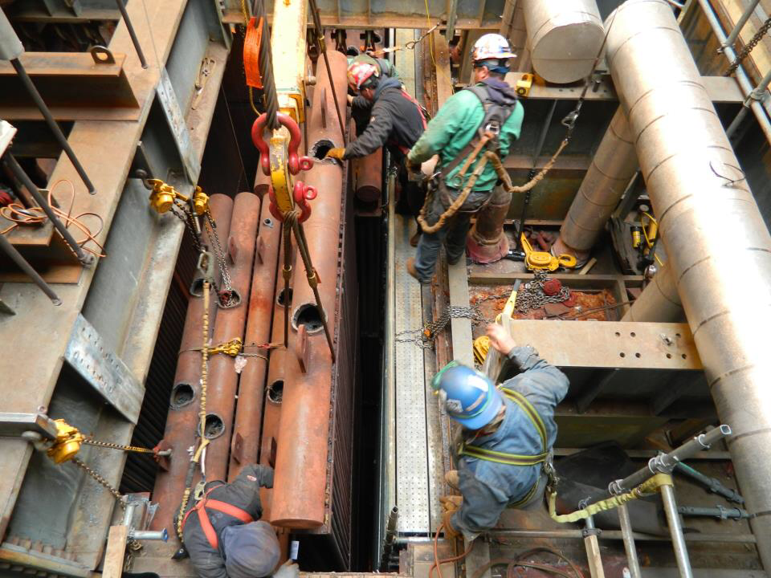
In advance of the work HDI’s advisor Zane Koos, a seasoned veteran of the HRSG industry, made a preliminary site-visit and detailed inspection of the units. This inspection led to minor repair suggestions to help reliability and operation of the unit for the customer. A handful of additional spare parts were ordered to fold-in these recommendations to the scope and schedule.

- Zane provided operational guidelines (blowing down level gauges, etc.) in additional to mechanical, execution and sequencing guidance.
- He also detailed all work executed in detailed reports for the customer’s files.

All was going smoothly when the customer conducted RT on a field weld connecting the existing piping to the new heat transfer panel.

- Customer believed they had shot a shop weld and called HDI’s attention to the matter for warranty remedy.
- It was not immediately apparent customer had accidentally shot the wrong weld…a field weld instead of the shop weld.
- Once the error was discovered a small indication was still found on the shop weld that had been questioned.
- HDI moved forward with a repair:

    - Technically shop weld in question did not require RT per ASME code or project requirements
    - HDI immediately dispatched 2 shop welders to repair the matter in the field
    - On HDI’s cost
    - From a shop (HDI) that was already full and on mandatory overtime
    - HDI developed an appropriate repair procedure
    - Contacted local Authorized Inspector, paper work and repair nameplate, etc.

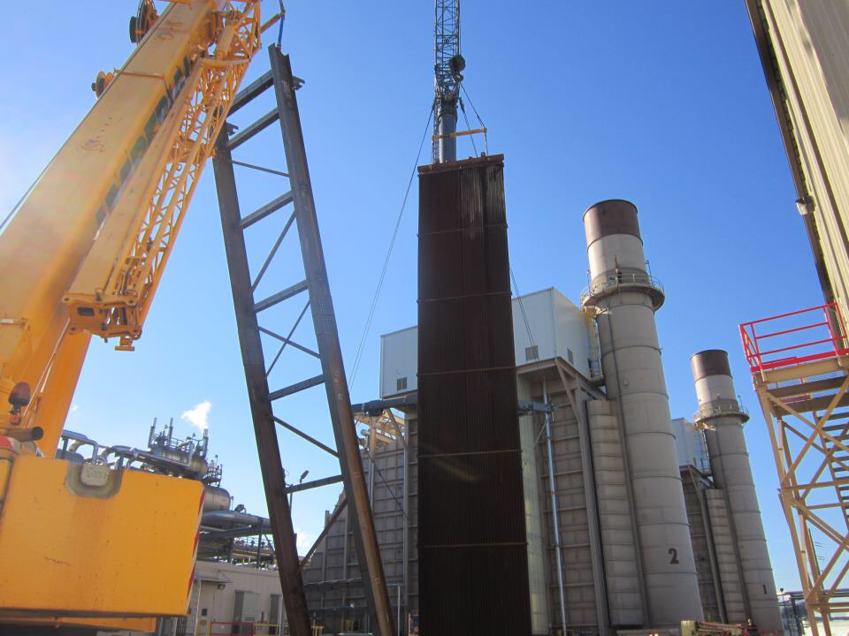
The result was a success as the customer was completely satisfied with the repair, service and caliber of support provided by Hamon Deltak. There were multiple points at which any other supplier might have dug-in their heels. But HDI prides itself on solid quality, workmanship and outstanding customer support.

This is just the latest example of Hamon Deltak taking care of my customers, and the level of customer care common to HDI and our products. Hamon Deltak Manager of Aftermarket, Trevor Maassen explains, “We don’t walk away, especially when we have a Field Service engineer onsite…this isn’t a “one-off” situation.”

